

**USMAN INSTITUTE OF TECHNOLOGY**

Affiliated with NED University of Engineering & Technology, Karachi

**Department of Computer Science**

B.S. Computer Science / Software Engineering

FINAL YEAR PROJECT REPORT

**Batch-2018**

**Automated News Reporting Channel**

**By**

|  |  |
| --- | --- |
| Yusra Masood | 18B-093-CS |
| Rushan Rafiq | 18B-087-CS |
| Yumna Asim | 18B-047-CS |
| Shiza Khan | 18B-130-CS |

**Supervised by**

Sir Abdul Hafeez Adam

*ST-13, Block 7, Gulshan-e-Iqbal, Abul Hasan Isphahani Road, Opposite Safari Park, P.O. Box 75300,*

*Karachi, Pakistan. Phone: 34978274-5; 34994305; 34982476;* [*http://www.uit.edu*](http://www.uit.edu/)

Declaration

I hereby declare that this project report is based on my original work except for citations and quotations which have been duly acknowledged. I also declare that it has not been previously and concurrently submitted for any other degree or award at USMAN INSTITUTE OF TECHNOLOGY or other institutions.

|  |
| --- |
| Student Name (Student ID): Yusra Masood (18B-093-CS) |
| Signature: _______________________________ |
| Student Name (Student ID): Rushan Rafiq (18B-087-CS) |
| Signature: _______________________________ |
| Student Name (Student ID): Yumna Asim (18B-047-CS) |
| Signature: _______________________________ |
| Student Name (Student ID): Shiza Khan (18B-130-CS) |
| Signature: _______________________________ |
|  |
| Date: ___3rd-December-2021____________________ |

Acknowledgments

This page should consist of the acknowledgements to the people, companies and institutions that have been helpful to the author in compiling the reports. It is normal practice to thank the Head of Institute for the use of facilities with which the project was carried out, the head of department, the supervisor for his/her suggestions and guidance and any other member of the academic and technical support staff who have made a significant contribution to the success of the project, and finally your family member (that is optional).

Abstract

The evolving technology has brought evolution in all the fields and news media and journalism are no exception. Research have been started on automating the process of news channel and in the next 10 years it might be the case that traditional journalism would be shifted to automated journalism or robotic journalism. This project aims to develop such automated news channel which can gather data required for the news, can filter out the required content from that data and then present it in the news format.

Table of contents

Contents

• Declaration Error! Bookmark not defined.

Acknowledgments 4

Abstract 5

Table of contents 6

List of tables 8

List of figures 10

List of symbols and Units 12

1. Introduction 13

1.1 Problem Statement 13

1.2 Proposed System 13

1.3 Summary of this Report 14

1.4 Future Enhancements 14

1.5 Block Diagram 15

1.5.1 Component 1: The admin portal 15

1.5.2 Component 2: Web Scrapper 17

1.5.3 Component 3: Sanitization of Data 17

1.5.4 Component 4: Text to Speech Conversion 18

2. Background and Literature Review 19

2.1 Background 19

2.2 Literature Review in terms of the mechanism of the system 21

2.2.1 Natural Language Processing (NLP) 21

2.2.2 Text to Speech Engine 22

2.3 Chapter Conclusion 27

3. Aim and Statement of Problem 28

3.1 Project aims 28

3.2 Project objectives 28

3.3 Stakeholders 28

3.4 Project Scope 29

3.4.1 In scope: 29

3.4.2 Out of scope: 29

4. Hardware, Software analysis and requirements 30

4.1 Product Perspective 30

4.2 User Categories & Characteristics. 30

4.2.1 User Requirements in User Stories form 30

4.3 Software Requirements 31

4.4 Hardware Requirements 31

4.5 Assumptions 31

5. Software design and modeling 32

6. Algorithm analysis and complexity 33

7. Implementation 34

8. Testing 35

9. Discussion (optional) 36

10. Conclusions 37

11. Future work 38

12. Achievements 39

13. Appendices 40

14. Bibliography 41

15. General Guidelines 44

15.1 Typing and size of paper 44

15.2 Page number and Chapter number 44

15.3 Margin boundaries 45

15.4 Diagrams and figures 45

15.5 Photocopying 45

15.6 Fixing of photograph 46

15.7 Tables 46

15.8 Equations 46

15.9 Units 46

15.10 References 46

15.10.1 Citations/references with multiple authors 47

15.10.2 Reference examples 47

15.10.3 Book 47

15.10.4 Book chapter 47

15.10.5 Electronic Book 48

15.10.6 Journal article 48

15.10.7 E-Journal article 48

15.10.8 Conference papers 49

15.10.9 Reports 49

15.10.10 Patents 49

15.10.11 Standards 49

15.10.12 Theses/Dissertations 50

15.10.13 Datasheets 50

15.10.14 Online Documents 50

15.10.15 Websites 50

The table of the contents is on a separate page and is numbered iii. The table of contents lists the sections of the report, a list of figures and a list of tables along with the page on which they begin. It is to be generated by MS word -> references -> table of contents, similarly list of tables and list of figures.

List of tables

List of figures

Figure 1‑1: Block Diagram (automated news reporting channel) 15

Figure 1‑2: Admin portal component 16

Figure 1‑3 : Web Scrapper Component 17

Figure 1‑4: Component for sanitization 17

Figure 1‑5: TTS Convertor Component. 18

Figure 2‑1: Methodology Flow Diagram (Research Paper) 20

Figure 2‑2: Output generated by the TVML Script (Research Paper) 20

Figure 2‑3: System model of portable text to speech convertor (Research Paper) 26

Figure 2‑4: A picture representing the android application (Research paper) 26

List of symbols and Units

A list of symbols and units should be included to assist the reader. This should include any Greek letters or other mathematical symbols together with the quantities to which they refer, and their appropriate units. Preferred 2-3 pages of UML notations used in the project.

# Introduction

There goes the saying that “The only difference between being uninformed and misinformed is that one is your choice and the other is theirs.” Sadly, this is becoming correct with the advancement in 21st century where the world faces an imminent information catastrophe to such an extent that we are constantly bombarded with lots & lots of information from different channels and mediums yet we ourselves are unsure which one is true, and which one is not.

## Problem Statement

The world is becoming increasingly dependent on technology. Gadgets, automated systems and modern equipment are now becoming a part of our daily life. Almost all the fields and disciplines have been affected by this revolution in technology and it wouldn’t be wrong if we say that journalism is one such field which has been impacted by it the most.

Journalism and in particular news media have been hugely influenced by the modern technology. It has never been this easy to develop, discover, produce and consume the news as it is now thanks to this technology. But all of this now comes at a price. We (as audiences) are usually unaware about whether the news shown is either true or not. With the growing easiness in the news media field, a competition has now arisen; each news channel is competing to produce more and more news in order to gain a higher amount of viewership and in the process of producing more content some people have taken an unethical route. Some channels now deliver fake, unauthentic, or incomplete news so they can increase their ratings or make more bucks.

A U.S. Representative for California's 34th congressional district once quoted that “When fake news is repeated, it becomes difficult for the public to discern what's real.” This has never been as accurate for our world as it is now. Constantly listening to fake news can remove your consciousness of what is true and what is false yet because of the increasing competitiveness you are fed on it, on daily basis through different channels and then one has to go on surfing at least three to four websites or channels to see if the said news is actually accurate or not.

## Proposed System

Thus, to solve the above problems we aim to design an automated news reporting channel. This system would be as such that it can scrap data from different news reporting sources/websites (to ensure the authenticity of the news), filter those data for authentic content only, aggregate, summarize and synthesize it and broadcast the final accurate news).

The proper step by step working of the system is as follows:

* There is an admin portal from where the admin would be able to edit the URLs (i.e., add new URLs, delete any previous unwanted URLs, enable or disable any URL etc.) or read the synthesized documents (news) and disable them if needed.
* From the given URL’s website, web scrapping technique is applied to gather the required data related to news content. This technique is applied after every set time interval period to refresh the new content.
* Once the data is scrapped it is filtered, summarized, and news is generated out of it.
* The generated news is then converted from written to oral form using text to speech library and presented to the user on the customer view page

## Summary of this Report

This Report aims to provide you with the information related to the development and working of the automated news reporting channel project. The report is divided into sections/chapters, each dealing with a particular topic. The chapter wise division of the report is as follows:

* The first chapter is the introduction part which is related to what were the problems that we found in the current news industry and what solutions do we aim to provide by building this project and how it can help tackle those problems.
* The second chapter is the background literature and review chapter which lay out the details of the research papers that we have find and studied to develop our system.
* The third chapter defines the aims and statements of the project. It tells about who the project stakeholders are. What are the scopes of the project and what are the technological issues that we faced during the development of the project.
* The fourth chapter provides details about the hardware and software requirements. It tells the details about the minimum hardware requirement that is needed to run the system as well as the software and their versions that are required to develop this system.

## Future Enhancements

For now, we would be narrowing down our domain so we would be working on only the weather-related news. In the future this project can further be enhanced to other domain’s news (such as sports, entertainment, current affairs etc.)

## Block Diagram

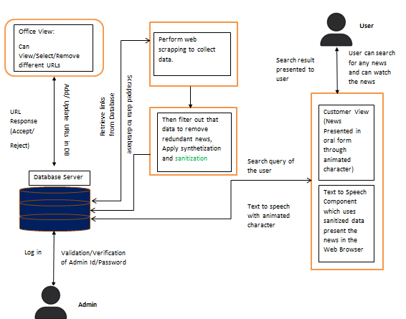

Figure ‑: Block Diagram (automated news reporting channel)

Figure 1.1 refers to the system diagram of this project. This system consists of four major components (represented in squares), each performing a separate task. Below are the details of each of the component.

### Component 1: The admin portal

Admin portal depicts the interface of the office view. It consists of a main dashboard (home page) a URL page and Document page. The URL page will let the user add, delete, edit, enable, or disable any URL. It would allow admin to fill data in the configuration table when adding a new URL. Figure 1.2 gives an overview of the admin portal component.

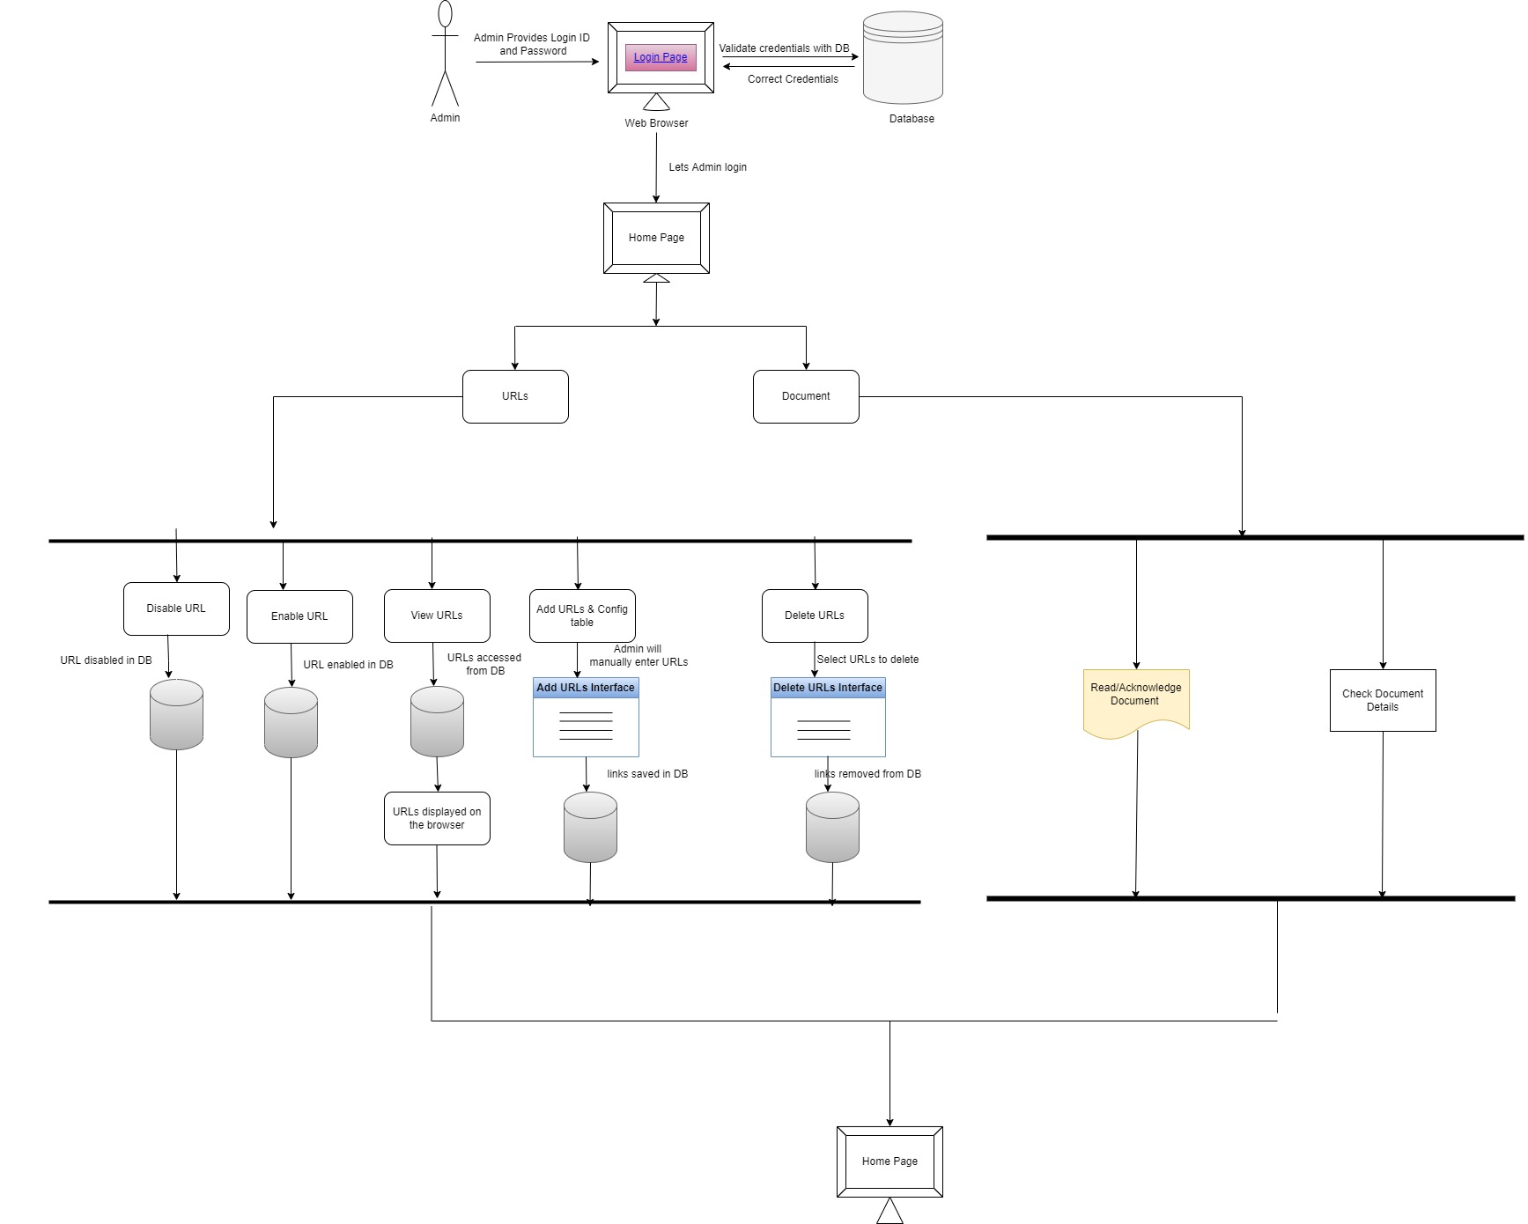

Figure ‑: Admin portal component

### Component 2: Web Scrapper

This component would be used to gather data from different websites. It would first access the links from the database, check if the links are active and then visit the website of that link and scrap the data from that website. The scrapped data would then be saved in the database again. Figure 1.3 depicts the structure of this whole component.

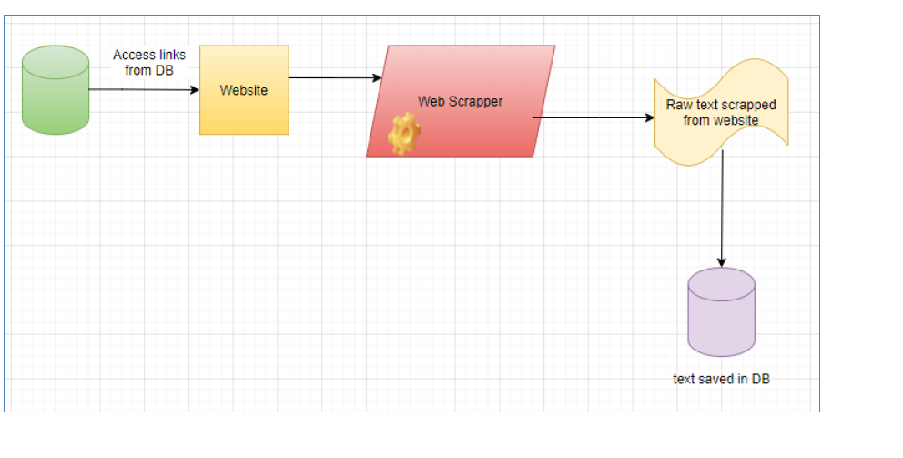

Figure ‑ : Web Scrapper Component

### Component 3: Sanitization of Data

This component would be used to filter out the correct information from all the scrapped data and then create a document using only the valid information. Figure 1.4 depicts the system diagram of this component

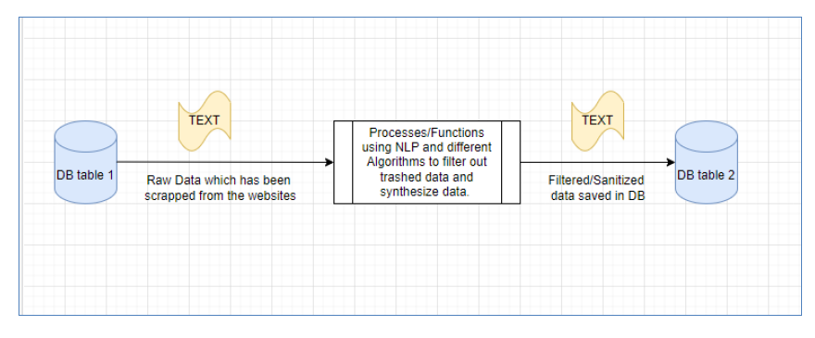

Figure ‑: Component for sanitization

### Component 4: Text to Speech Conversion

This component would be used to convert the written news into speech for user to be able to listen to it. Figure 1.5 depicts its diagram.

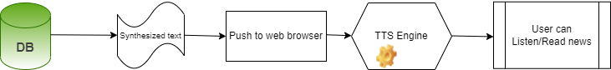

Figure ‑: TTS Convertor Component.

# Background and Literature Review

This section aims to provide the reader with an overview of the literature, which is relevant to our project, Automated News Broadcasting Channel.

## Background

Our topic aims to create an Automated News Channel whose sole purpose is to automate the process of news channel. Previously it was the job of journalists to gather data from different sources go through each of those collected data stuff and then form useful news out of it. Now, with the advent of the advanced and constantly evolving technology computer software and robots could be made to do any such task as well.

Therefore, we plan to develop one such website whose working would be such that it automatically gathers data from different websites (using web scrapping), extract useful information from that data (using Natural Language Processing) and use a CG character to present it. Currently there is no implementation of it on large scale. However, some research paper authors have given this idea in their research/research papers or some similar applications have been made such as Dante; a robot journalist developed in Pakistan to help write reports for Pakistan Stock Exchange. [1]

We made use of the research paper [2] as well as ideas from [3, 4, 5] while brainstorming for our idea of FYP. In Research paper [2] they proposed an application software which can be used to convert any written blog posts to news with the aid of the TV program Making Language (TVML). The main idea and methodology used in research paper [2] is given down below:

This paper aimed to automate the system for news generation and presentation to address the journalism related issues such news biasness, fake news etc. The Paper described the development of an application which makes use of TVML (TV programs Making Language) to create news scripts using the data scrapped from web and the different TVML techniques such as camera angle, artwork etc. (such techniques would be used to generate appropriate pictures suitable to the content of the news). In the end it applies a CG character to present the news.

**Approach/Technique Used:** The system starts with scrapping data using a web scrapper. This is the plane text which is then passed from NLP Processing (to summarize it). Those summarized sentences, title etc. are passed from an APE Script generator and then an APE engine to generate a TVML script. This TVML script is then passed through TVML Engine and is presented using a CG character.

Figure 2.1 shows the flow chart of the methodology of the system.

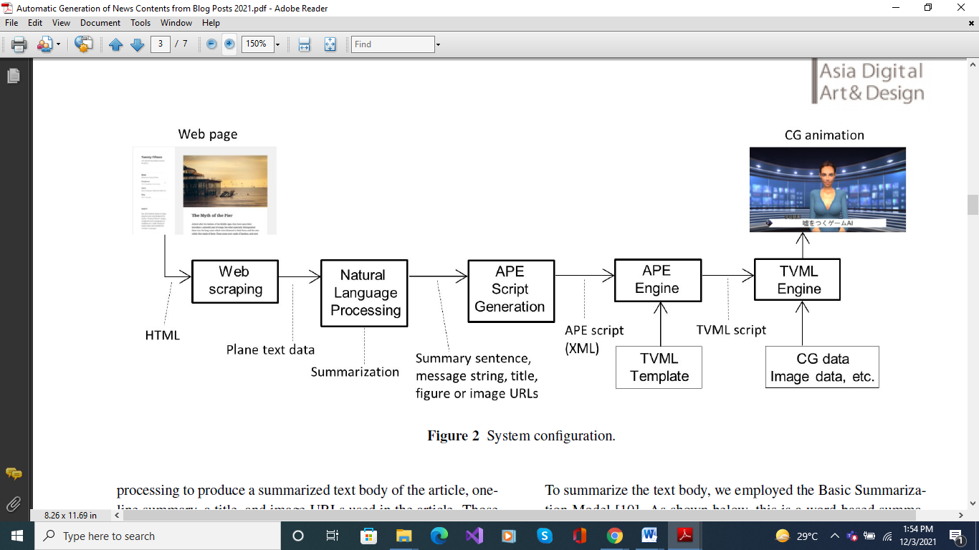

Figure ‑: Methodology Flow Diagram (Research Paper)

**Experimental Setup and Results:** 2 experiments were conducted to define the accurateness of the system. The first one aimed to obtain a message string and a message title. For this experiment 53 articles were given to the system and the system was supposed to generate the content from that. The second experiment aimed at automatically developing suitable artwork, sound effects etc. for the given news script.

The result for first experiment showed that out of 22 generated strings (of sentences), 12 strings were correct i.e., it gave an accuracy of 55%. For second experiment the result did generate some CG characters and text strings to appear when the news channel starts. An example of one such output screen is given in figure 2.2

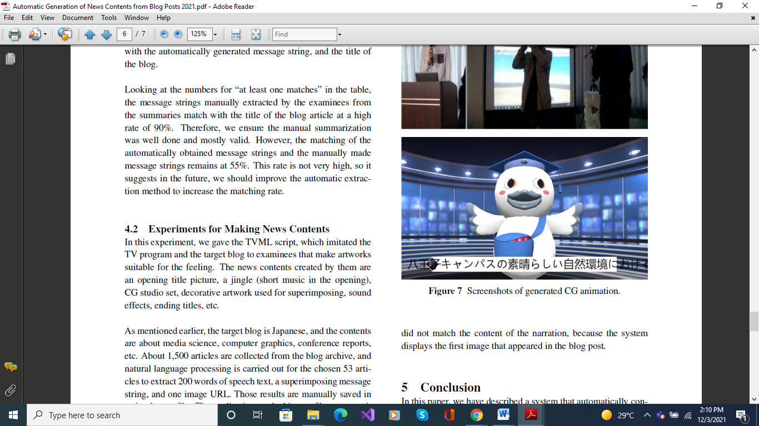

Figure ‑: Output generated by the TVML Script (Research Paper)

**Future Work:** As Described in the paper their future work includes integrating all of the elements of the news and generating images that are relatable to the news content and generating a more natural CG character as compared to just an avatar.

## Literature Review in terms of the mechanism of the system

Our system as mentioned in Figure 1.1 comprises of 4 components. The first is the admin portal and the second one is the web scrapping component. The third one is the NLP processing component and the fourth and final one is the Text to Speech convertor component. The major ones of these 4; Web scrapping, NLP and Text to Speech plays a significant role in the development of this system. Below we explain the details related to these components further

### Natural Language Processing (NLP)

Natural Language Processing is a branch of Artificial Intelligence which is concerned with processing the human input to achieve desired output. A general example of this can be Siri or chat bots which processes the question that its user asks it and then present the user with that specific output or performs that desired task. Another more specific example could be using NLP to analyze reviews such as reviews about a restaurant and using those reviews to rate the restaurants. Technically NLP has made it possible to process huge amount of data on webpages in less amount of time and it is because of this that we are now able to achieve these fast speeds of google and the internet. NLP makes use of different algorithms to process this data such Seq2Seq, Support Vector Machines etc. Below we have included a detailed description of the research papers that we found useful while researching on NLP

**Paper name:** Natural Language Processing[6]

The objective of this research paper was to make reader aware of what exactly is NLP and how its algorithms can help in different processing techniques. Some of the algorithms defined in this paper are as follows:

**Algorithm used for efficiency of processing the language in text:**

* Long short-term memory
* Sequence 2 Sequence model
* Named Entity Recognition model
* User preference graph model
* Word Embedding model
* Feature based sentence extraction using fuzzy inference rules.
* Template based algorithm using automatic text summarization,

**Algorithm for speech form efficiency**:

* Word Recognition
* Acoustic Modeling
* Connectionist temporal classification
* Phase based machine translation
* Neural machine translation
* Google neural machine translation

Although this paper provided us with a very vast overview of NLP (where each of these algorithms might not be very useful in the development of our project), it helped us gain an understanding of what NLP is and what is the basic role of it in the field of computer science

**Paper Name:** FLAIR: An Easy-to-Use Framework for State of the Art NLP [7]

**The objective of this research paper is to present a simple and easy framework for NLP.** The core idea of the framework is to present a simple, unified interface for conceptually very different types of word and document embeddings. This effectively hides all embedding-specific engineering complexity and allows researchers to “mix and match” various embeddings with little effort

**Approach/ Technique: A PyTorch NLP framework:** Framework builds directly on [PyTorch](https://pytorch.org/), making it easy to train your own models and experiment with new approaches using Flair embeddings and classes.

**Data Set Details:** FLAIR includes convenience methods for downloading standard NLP research datasets and reading them into data structures for the framework. It also includes model training and hyperparameter selection routines to facilitate typical training and testing workflows. In addition, FLAIR also ships with a growing list of pre-trained models allowing users to apply already trained models to their text

**Experimental Setup**: FLAIR only requires a current version of Python (at least version 3.6) to be available on a system or a virtual environment. Then, the simplest way to install the library is via pip, by issuing the command: pip install flair. This downloads the latest release of FLAIR and sets up all required libraries, such as PYTORCH. Alternatively, users can clone or fork the current master branch of FLAIR from the GitHub repository. This allows users to work on the latest version of the code and create pull requests. The GitHub page1 has extensive documentation on training and applying models and embedding.

**Limitations/ Assumptions:** Not all word and document embeddings are currently supported by FLAIR, such as class CharacterEmbeddings.

### Text to Speech Engine

Text to Speech (TTS in short) is used to convert a desired text into a speech form. With more advancement in technology TTS engines became a necessary component to take inputs and give outputs in speech form as opposed to the previous computers which used only the written input from keyboards or typewriters. Today TTS APIs are provided by Google, Amazon (Amazon Polly API), IBM (IBM Speech to Text API) etc. Below we have provided a deatiled descriptions of the research papers that we made use of while researching on different open-source TTS APIs as well as some of the systems which created their own TTS engine and simultaneously their pros and cons

**Paper Name:** End-to-end conversion speed analysis of an fpt. ai-based text-to-speech application [8]

**Objective of this Research**

The main objective of the research is to design an application that takes three inputs from user i.e., text, speech, and voice and convert the text into speech and returns a converted audio file as well. It's mainly focused on the relationship between the end-to-end conversion time and the length of the input text.

**Major Contribution/ Gaps Addressed**

Creating a text-to-speech (TTS) application that is linked with FPT.AI server via it's API, to convert the text into seven different Vietnamese speeches. Also, they have addressed that end-to-end conversion time is depends on the length of the input text i.e. if the length of text increases then the time taken by the TTS to perform task will be increases as well.

MOS (main opinion source) is one of the parameter of TTS system that is used to measure the naturalness of the generated speech.

**Approach/ Technique Used**

To achieve their goals, they propose an approach that uses FPT.AI API to link the connection between local host and remote FPT TTS server. In this approach TTS API gets four arguments from the user to generate http request before posting it to the server i.e., the POST data that holds the text that is converted into speech, the second input is the speed of voice and the voice category. Once it'll gets the input it'll generate the request to the server. For every request server will returned the response to host application and provide a http link to downloads the converted audio file in *.mp3.

**Evaluation/Testing Technique**

After evaluation they have measured the performance of the system that, as far as the length of input text is directly proportional to the end-to-end conversion time to obtain the converted speech that is 500-character input text will take 9s to 10s to converted into speech as compared to 400-character input text.

**Limitations/ Assumptions**

The Assumptions of the applications are:

* The length of input text is based on 10, 100, 200, 300, 400, and 500 characters.
* They have set the speed of voice to zero by default.

They have set the Thu Dung voice as the default voice of the application.

**Paper Name:** Comparing Speech Recognition Systems (Microsoft API, Google API and CMU Sphinx) [9]

**Objective of the Research**

Comparing Different Speech Recognition Systems

**Major Contribution**

Providing research regarding how Google API is Superior to other recognition systems

**Approach/ Method/ Technique**

CMU SPHINX version-4 three main components in the Sphinx-4 structure, which includes the Frontend, the Decoder and the Linguist -Frontend implementations support MFCC, PLP, and LPC feature extraction. -the Linguist implementations support a variety of language models, including CFGs, FSTs, and N-Grams; and the Decoder supports a variety of Search Manager implementations. Microsoft has focused on increasing emphasis on speech recognition systems and improved the Speech API (SAPI) by using a context dependent deep neural network hidden Markov model (CD-DNN-HMM) THE GOOGLE API Google has improved its speech recognition by using a new technology in many applications with the Google App such as Goog411, Voice Search on mobile, Voice Actions, Voice Input (spoken input to keypad), Android Developer APIs, Voice Search on desktop, YouTube transcription and Translate, Navigate, TTS.

**Data Set Details**

TESTING DATA The audio files were selected from various sources to evaluate the Microsoft API, Google API, and Sphinx-4. According to CMUSphin, Sphinx-4's decoder supports only one of the two specific audio formats (16000 Hz / 8000 Hz). WAV files not supported by all three so they design tool which recognition all audio files in the same format (16000 Hz / 8000 Hz). The TIMIT corpus of read speech is designed to provide speech data for acousticphonetic studies and for the development and evaluation of automatic speech recognition systems. “The TIMIT corpus includes timealigned orthographic, phonetic and word transcriptions as well as a 16-bit, 16kHz speech waveform file for each utterance. Corpus design was a joint effort among the Massachusetts Institute of Technology (MIT), SRI International (SRI) and Texas Instruments, Inc. (TI)” audio files from ITU (International Telecommunication Union) which is the United Nations Specialized Agency in the field of telecommunications.

**Experimental Setup**

In this paper they have developed a tool that is used to test these models in Microsoft API, Google API, and Sphinx4. Also, they calculated the WER by using this tool to recognize a list of sentences, which we collected in the form of audio files and text translation. In this paper, they follow these steps to design the tool and test Microsoft API, Google API, and Sphinx-4. This system has been designed by using the Java language, which is the same language that has been used in Sphinx-4, as well as the C# that was used to test the Microsoft API and Google API. Libraries such as Text to Speech API, Graph API and Math API for different tasks. Moreover, this tool was connected with the classes of Sphinx4, Microsoft API and Google API to work together to recognize the audio files. Then we compared the recognition results with the original recording texts. calculated the word rate (WER) and accuracy according to these equations. WER = (I + D + S) / N WER = (0 + 0 + 1) / 9 = 0.11 where I words were inserted, D words were deleted, and S words were substituted. The original text (Reference): the small boy PUT the worm on the hook The recognition text (Hypothesis): the small boy THAT the worm on the hook

Accuracy = (N - D - S) / N

WA = (9 + 0 + 1) / 9 = 0.88

**Results**

The Sphinx-4 (37% WER), Google Speech API (9% WER) and Microsoft Speech API (18% WER). Where S sentences, N words, I words were inserted, D words were deleted, and S words were substituted. CW correct words, EW error words Google is Superior

**Paper Name:** Portable Text to Speech Converter for the Visually Impaired [10]

The main objective of this research is to design an application which helps the partially vision loss people by scanning the image from any book or document and then convert the extracted text into speech form. In particularly they designed this app for android mobiles.

**Method/Technique Used:** To achieve their goals, they apply a technique i.e. firstly the scanner scanned the page containing text, graphs or images, etc. then it sends it to an android application which is connected through Bluetooth module. After sending it to android application the Tesseract optical character recognition (OCR) library will extract the plain text from the scanned image and once the text is extracted then the library text to speech (TTS) is used to convert the text into speech.

**Experimental Setup & Results**

The Experimental setup works as firstly the scanner scan the document, then transfer scanned file to android phone over Bluetooth them its check whether the file was transfer successfully or not? If no, then it will retransfer it or else it will open the most recently received file in the application. After it will extract the text from the opened file in the application and convert extracted text into speech.

Figure ‑: System model of portable text to speech convertor (Research Paper)

Figure ‑: A picture representing the android application (Research paper)

**Limitations/ Assumptions:**

The Assumptions of the applications are:

* The scanner should be placed in horizontal to the scanned document.
* The application is only for the android mobile phones and not for the apple iPhone OS.
* Android phone must be within the range of Bluetooth of the scanner.

## Chapter Conclusion

The use of automated journalism/ news reporting channels might become a more common thing in the next ten years. It might be the case that in future automated journalism would completely replace the traditional journalism system. According to some studies automated journalism produces less biased and more accurate news content as opposed to traditional journalism [11] [12] (though they also mention about some other limitations [12])

According to [13], The Czech News Agency (a national news service provider for the Czech Republic) introduced the robotic journalism in their organization for study and experimental purposes. In particular they dealt with the financial side and Prague stock exchange during this research. According to their research paper they were able to generate valid content during their research phase. However, because of the complex nature of the financial system, the system still required some human input as well.

# Aim and Statement of Problem

This section defines the aims of the project we are intending to make and the objectives/statements we intend to take to achieve those aims.

## Project aims

To solve for the problem as described in the introduction section we aim to develop an automated news reporting channel whose sole purpose would be to deliver complete and authentic news content in rapid time. Consequently, this system further aims to save the precious time of user as he doesn’t have to go on navigating different news related websites finding for any news or checking for whether it is authentic or not. Accordingly, authenticity along with reliability and fastness are the major goals of this system.

## Project objectives

The automated news reporting channel project aims to achieve the following objectives:

* Provides an easy to use, user friendly platform for viewers who can use it to watch any current news.
* It will help in providing user with fast access to the news which can approximately safe 10% of their time that was wasted in browsing and surfing for genuine news.
* It will further help in reducing the consumption of fake/unauthentic news in the people by approximately 10-20%

## Stakeholders

The primary stakeholders of this project include the following:

1. The Development Team

This includes Project Manager, the dev-team members responsible for making the software product and the designers responsible for designing a user-friendly UI of the product

The secondary stakeholder of this project includes:

1. News Viewer: The one who would use our product and would be benefited from it. In our case the user can be anyone provided he knows the use of internet/browser and is familiar with English language.
2. Admin: The admin who is the one to manage the system, edit URL links or check the generated news report.
3. Journalists: Automated news channel can help journalists, searching for news content, find accurate news content in less amount of time.

## Project Scope

Project scope includes a detailed description of all the tasks activities and goals of the project. The scope of this project includes and excludes the following items.

### In scope:

* The development of an automated news reporting channel to produce genuine news content
* This System would be based on weather related news only
* NLP based training of the system so that the system could produce the correct and accurate results
* Development of graphics for the website which could give user a more user friendly and responsive website feel
* Testing of the system before making it accessible for the public

### Out of scope:

* Further enhancement of this system in other news related fields (such as entertainment, current affairs)
* Enhancement of system such that present the news with relevant pictures.
* With the use of cookie can show the news related to user’s preferences.
* Rather than using animated character, video can be generated using related images/news
* Development of mobile app for this system

# Hardware, Software analysis and requirements

This section discusses the requirements needed to build this system as well as the requirements a user/customer of our application would require to use it.

## Product Perspective

The system would consist of a web-based application which can be run on any browser with the internet connection. It is a software-based project so doesn’t require any strict hardware requirements except for a device to view the web page. The system consists of two types of users: the news viewer and the administrator.

The proper detailed requirements are explained further

## User Categories & Characteristics.

This system has users divided into 2 categories:

1. News Viewers: They are the normal viewers who would visit the website to watch the news. The news viewers can be of any age and should be familiar with English language because the news would be broadcasted in English.

A news viewer would require a device such as a PC along with a stable internet connection to view the website.

1. Administrator: An administrator would manage the system. He would be the one to add the URLs of the websites, make their configuration tables etc.

### User Requirements in User Stories form

In a survey that we conducted with our closed family members and friends we explained to them our project and asked them what they would expect this project can do for them and how it can help them. Below we have outlined those details in the form of user stories:

* As a news viewer I want authenticity in the field of journalism, so I get to hear less number of biased news.
* As a news viewer I would want to hear more about the news content, so I get to hear less about ratings and praises related to a TV channel
* As a journalist I would want to search for authentic data only so automated news channel can give me perfect way to search for genuine content.

## Software Requirements

* IDE: Visual Studio (version 16.11.5)
* Programming Languages: Python/Django, CSS, JavaScript, HTML5
* Database: My SQL server along with MySQL workbench (version 8) to help coordinate with the database related activities.
* Operating System: It can run on any operating system such as Windows, Linux, and MAC. The operating system would need a browser installed on it which can run the website.

## Hardware Requirements

Since this is a software project so hardware requirements are very basic and general. The hardware requirements are as under:

* Processor: Intel i5 or later/AMD Ryzen 5
* RAM: 4.00GB
* Hard disk: Minimum amount of it required to run the computer.
* Internet Connection: A stable internet connection with a speed of at least 4-5Mbps for good experience

## Assumptions

* We’re assuming that the user is familiar with the know-how of how to use an internet.
* User is familiar with English language since the system only works on English news content.

# Software design and modeling

In this chapter project architecture is presented (explain which architecture is used), overall design diagrams (complete object diagram, complete class diagram, database diagram, etc.) to be shown. (as such diagrams are usually huge in nature, it is appropriate to print in on A3 or bigger sheets, and then fold it to A4 size).use few behavioral diagrams (sequence diagram, timing diagram, activity diagram, state transition diagram, or composite diagram) only for core technical functionality of the project against use cases. Also show high fidelity prototypes against each use case.

# Algorithm analysis and complexity

In this chapter you have to mention algorithms that are used in project. Its purpose and significance, along with its pseudocode. Compare your selected algorithm with such other algorithms. For each algorithm show its best, average, and worst values in context of time and space complexity. Show primary references of all mentioned algorithms.

# Implementation

Give code details (not a complete listing, but description of key parts). Discuss the most important/interesting aspects. It probably won’t be possible to discuss everything- give a rationale for what you do. Code shall not be more than 3-5 pages. Use appropriate code writing standards, draw operational diagram, component diagram and deployment diagram. Show only two to three technical interfaces that represents the core project functionality with explanation (You may use POC interfaces). Draw state transition diagram of project interface (input, output, and processes).

# Testing

This chapter contains Whitebox of most logical code, and black box testing of that interfaces that represents core functionality of the project. Some of the system level structural and functional testing must be shown with the help of tools. You have to show test plan – how the program/system was verified. Put the actual test results in the annexure.

This chapter also covers results of different types of experiments/simulations that were carried out with the code written. Why were certain experiments in the simulation used and how did they affect the results? If there are very many graphs and tables associated with this Chapter they may be placed in annexure.

# Discussion (optional)

This Chapter should fully and logically discuss the progression of the project including the methods used and the results of experimentation, or the design; in such a way that examiner can evaluate the worth of the project. The discussion should be backed by detailed reference to material in the testing chapter of the report.

# Conclusions

This Chapter should be a concise statement of the conclusions which may be drawn from the work attempted. The reader needs to be convinced that the design will work. If

Uncertainties remain, they should be pointed out, and alternatives, such as modifying performance specifications, should be spelled out to deal with foreseeable outcome.

# Future work

This Chapter may be used to propose further work which may be carried out on the project in subsequent study projects. Suggestions of this type should be limited to proposals which involve significant amounts of work such as major modifications of equipment or development of student practical experiments/enhancement. If any component is developed, how it can be utilized with proper documentation. Any suggestion is to be given in sufficient detail to provide adequate information for a future student to be able to fully appraise the proposal. which other similar project can be developed by using same concept with different domain/technology.

# Achievements

In this chapter you have to summarize your participations in different competitions, conferences, incubation activities, and exhibitions. It is desired to express your experience about such activities. Also mention what you achieved in such activities e.g experience, acknowledgement, certificates, souvenirs , and rewards

# Appendices

These shall be used to give detailed results that shall be summarized in main text. The normal practice is “Annex A, B, C…” and, when required, “Appendix (to annex) 1, 2, 3…..” They should identify on every page by running header. Following items should be included in appendices

In **acknowledgement chapter**, you may include official letters from organizations.

In **introduction chapter** 2-3 pages about organization for which you are developing the project

In **background and literature review chapter**, research paper that is basis of your project, details of similar projects, any UML diagrams from other sources that has strong relationship with your project

In **hardware, software analysis and requirement,** you may add hardware pacification, use case narrations, or detailed requirement specification document.

In **software design and modeling chapter**, you may add detailed design documents other than most significant.

In **software algorithm and complexity**, you may attach actual algorithm or its research paper.

In **achievement chapter**, you have to mention correspondence (letters, emails etc.), copy of certificate, pictures of participation specially at time of award ceremony.

You may add any detail that is summarized in any chapters but need more focus and clarity for reader.

# Bibliography

|  |  |
| --- | --- |
| [1] | Z. Ahmed, "pakwired," 5th October 2017. [Online]. Available: https://pakwired.com/robot-journalist-dante-an-ai-content-creator. [Accessed 3rd December 2021]. |
| [2] | M. Hayashi, B. Steven, T. Naoya, T. Takehiro , K. Yoshihisa and S. Kazuo , "Automatic Generation of News Contents from Blog Posts.," *International Journal of Asia Digital Art and Design Association,* Vols. 25, no. 1 , pp. 1-7, 2021. |
| [3] | Anon, "Wikipedia," June 2017. [Online]. Available: https://en.wikipedia.org/wiki/Automated_journalism. |
| [4] | Douke, Mamoru, M. Hayashi and a. E. Makino., "Automatic generation of television news shows from given program information using TVML," *Journal of The Institute of Image Information and Television Engineers,* vol. 7, pp. 1097-1103, 2000. |
| [5] | M. Hayashi, U. Hirotada , K. Tsuneya and Y. Michiaki , "TVML (TV program making language): Automatic TV program generation from text-based script," *The Institute of Image Information and Television Engineers,* vol. 23.4, pp. 1-8, 1999. |
| [6] | Jain, Aditya, G. Kulkarni and V. Shah., "Natural language processing.," *International Journal of Computer Sciences and Engineering ,* vol. 6 no. 1, pp. 161-167, 2018. |
| [7] | Akbik, Alan, T. Bergmann, D. Blythe, K. Rasul, S. Schweter and R. Vollgraf., "FLAIR: An easy-to-use framework for state-of-the-art NLP.," in *n Proceedings of the 2019 Conference of the North American Chapter of the Association for Computational Linguistics (Demonstrations),*, 2019. |
| [8] | Chung, T. Duc, M. Drieberg, M. F. B. Hassan and A. Khalyasmaa., "End-to-end conversion speed analysis of an fpt. ai-based text-to-speech application.," in *In 2020 IEEE 2nd Global Conference on Life Sciences and Technologies (LifeTech)*, 2020. |
| [9] | Këpuska, Veton and G. Bohouta, "Comparing speech recognition systems (Microsoft API, Google API and CMU Sphinx).," *Int. J. Eng. Res. Appl,* Vols. 7, no. 03 , pp. 20-24, 2017. |
| [10] | K. Ragavi, P. Radja and a. S. Chithra., "Portable text to speech converter for the visually impaired.," in *In Proceedings of the International Conference on Soft Computing Systems*, New Delhi, 2016. |
| [11] | M. Haim and G. Andreas, "Automated news: Better than expected?.," *Digital journalism,* Vols. 5, no. 8, pp. 1044-1059, 2017. |
| [12] | Wu and Yanfang, "Is automated journalistic writing less biased? An experimental test of auto-written and human-written news stories.," *Journalism Practice ,* vol. 14 no. 8, pp. 1008-1028., 2020. |
| [13] | Moravec, Václav, V. Macková, J. Sido and K. Ekštein, ""THE ROBOTIC REPORTER IN THE CZECH NEWS AGENCY: AUTOMATED JOURNALISM AND AUGMENTATION IN THE NEWSROOM," *Communication Today ,* Vols. 11, no. 1, 2020. |
| [14] | J. Višnovský, U. Magdaléna and K. Karina , "Robo-Journalism and Its Implementation in Editorial Practice," in *NORDSCI*, 2019. |
| [15] | X. Liu, . N. Armineh, . L. Quanzhi, S. Sameena , M. Robert and D. John , "Reuters tracer: Toward automated news production using large scale social media data," in *IEEE International Conference on Big Data (Big Data)* , 2017. |
| [16] | C. Clerwall, "Enter the robot journalist: Users' perceptions of automated content," *Journalism practice.,* Vols. 8 no,5, pp. 519-531, 2014. |
| [17] | Aru, O.E., C. N. Ubochi and C. Ihekweaba, "DEVELOPMENT OF AN INTELLIGENT WEB BASED DYNAMIC NEWS AGGREGATOR INTEGRATING INFOSPIDER AND INCREMENTAL WEB CRAWLING TECHNOLOGY.," *LAUTECH Journal of Engineering and Technology,* Vols. 15, no. 1, pp. 11-22, 2021. |
| [18] | M. Hayashi, S. Bachelder and M. Nakajima., "Automatic CG Talk Show Generation from the Internet Forum."," in *SIGRAD2016*, 2016. |
| [19] | Hayashi, Masaki, M. Douke and N. Hamaguchi., "Automatic TV program production with APEs.," *In Proceedings. Second International Conference on Creating, Connecting and Collaborating through Computing,* pp. 20-25, 2004. |
| [20] | Sirisuriya and D. S., "A comparative study on web scraping.," 2015. |
| [21] | Glez-Peña, Daniel, A. Lourenço, H. López-Fernández, M. Reboiro-Jato and F. Fdez-Riverola., "Web scraping technologies in an API world.," *Briefings in bioinformatics ,* vol. 15 no.5, pp. 788-797, 2014. |
| [22] | Conneau, Alexis, D. Kiela, H. Schwenk, L. Barrault and A. Bordes., ""Supervised learning of universal sentence representations from natural language inference data."," 2017. |
| [23] | Artetxe, Mikel and H. Schwenk, "Massively multilingual sentence embeddings for zero-shot cross-lingual transfer and beyond.," *Transactions of the Association for Computational Linguistics,* vol. 7, pp. 597-610, 2019. |
| [24] | Maas, Andrew, R. E. Daly, P. T. Pham, D. Huang, A. Y. Ng and C. Potts., "Learning word vectors for sentiment analysis.," in *In Proceedings of the 49th annual meeting of the association for computational linguistics*, 2011. |
| [25] | Socher, Richard, Y. Bengio and C. D. Manning, "Deep learning for NLP (without magic)," *In Tutorial Abstracts of ACL 2012,* p. 5, 2012. |
| [26] | Li, Jiwei, X. Chen, E. Hovy and D. Jurafsky., "Visualizing and understanding neural models in nlp.," *arXiv preprint arXiv:1506.01066 ,* 2015. |
| [27] | K. P and Joszhi.A, "Application of Web Scraping and Google API service," *IEEE Transactions on Knowledge and Data Engineering,* vol. 6 No 4, 2014. |
| [28] | D. Zihang, Z. Yang, Y. Yang, J. Carbonell, Q. V. Le and R. Salakhutdinov., "Transformer-xl: Attentive language models beyond a fixed-length context.," *arXiv preprint arXiv:1901.02860,* 2019. |
| [29] | A. Brito, Blender 3D, Novatec, 2007. |
| [30] | R. Lawson, Web scraping with Python, Packt Publishing Ltd, 2015.. |
| [31] | L. Flavell, Beginning blender: open source 3d modeling, animation, and game design., Apress, 2011. |

# General Guidelines

- Begin each chapter on new page.

- Each chapter should have small introduction at beginning of chapter. Introduction must link to previous chapter. It is a one or more then one paragraph but not more than one page that introduces the reader to the subject. The introduction presents basic background material, the history of the problem and contains the key sentence outlining the subjects to be discussed.

The total report length should under no circumstances exceed **120 pages**; most projects somewhat shorter. There is no value in trying to artificially lengthen your project by ‘padding’ it. Each project is unique and has its own natural length, and you will probably know when you have said everything that you need to be said.

## Typing and size of paper

I. The report is to be typewritten on one side of the paper on international size A4 paper (297mmX210mm). This paper must be good quality bond (70-90 gsm).

ii. Reports length should be 80-120 pages.

iii. Use Times New Roman, size 12 font throughout the reports.

Use 1.5 or double spacing.

## Page number and Chapter number

- Use lower case Roman numerals for preliminary pages

I. Title page (not numbered on page)

ii. Abstract

Table of Contents

The text of the report begins with Arabic number 1. Number all pages. Page numbers can be inserted either at the bottom/top right or the bottom/top center.

All appendices should number as A-1, A-2, etc. for pages under appendix A, and B-1, B-2, etc. for pages under appendix B (See Table of Contents.).

A hierarchical numbering scheme for chapter numbering shall be used. For instance, use 1 for chapter one, 2 for chapter 2, 1.1 for the subsection 1 of chapter 1, etc. (See the Table of Contents).

## Margin boundaries

I. 1 -inch left margin.

ii. 0.5-inch margin on the other three sides.

## Diagrams and figures

Figures and table should be inserted in the text in one of the three places

A full page figure or illustration must be inserted on the left hand side facing the typescript which described it.

Small figure should be incorporated in the text with the legend appearing below (not recommended).

Each graph, figure, etc., should have a figure number and title typed below it. The type style should be same as the text. Figures should be numbered by chapters (Fig. 1.1, Fig 1.2, Fig. 2.1, etc). explain each figure by referring its number (e.g. in Fig 1.1), don’t assume any figure is self-explanatory. Whichever numbering system you use, make sure that you follow the same system for tables and equations, also explain then as figures.

Line drawings, graphs, and monograms should be in bold clear lines. Where graphs, diagrams and figures cannot be mounted vertically on the page these are to be mounted and labeled in such a way that they can be read from the right hand side(900 on the page) of the page .

All the axes of graphs are to be labeled with the parameter and its units. Information on illustrations and graphs such as labels, scales etc. must be typewritten.

## Photocopying

All the figures, etc. must be reproduced by an electronic or electrostatic or photographic method which is known not to fade.

## Fixing of photograph

Full page photographs should be bound into the report. Small photographs must be firmly fixed to the paper. An alternative is to use color photocopying or digital processing.

## Tables

Each table should be numbered consecutively (Table 1, Table 2) or by chapter (Table 1.1, Table 1.2, Table 2.1).Table number should be centre above the top of the table and be followed on the next line by a brief descriptive caption, preferably in cap. The type should be the same as the text. Refer to each table in text by number “In Table 1, one can clearly see………”The same rules for location of figures apply to tables.

TABLE 1. MEASURED RESISTOR VALUES AND THE METER ERROR

|  |  |  |
| --- | --- | --- |
| Nominal Value Marked | Measured Value | Error (%) |
|  |  |  |
|  |  |  |

## Equations

Centre each equation on separate line. Number equations consecutively in parentheses at the right margin. Equation may be referenced by number in the text, using parentheses around the number.

Y (t) = ∫sin (x) dx (1)

## Units

The S.I. system of units is to be used throughout. Where difficulties are introduced by quotation of imperial units from reference source, these should be accompanied by the appropriate conversion to S.I. units in parentheses.

## References

At the end of your work, list full details of all of the sources which you have cited in your text in a section headed *References*, in numeric order. References listed must follow IEEE formatting guidelines (see reference examples overleaf). Your reference list should allow anyone reading your work to identify and find the material to which you have referred.

In IEEE style your reference list should be formatted in the following way:

* Align references left
* Single-space each entry, double-space between every new entry
* Place number of entry at left margin, enclose in square brackets [ ] Indent text of entries

### Citations/references with multiple authors

If you choose to mention the author(s) of a source whilst citing it in the text of your work, if there are three or more you can abbreviate them using ‘et al.’ e.g. During their research, Fan, et al. [4] discuss lasers in detail. However, in general you do not need to mention the authors by name, just use the numeric citation in square brackets. In your full reference list at the end however, you always give the authors’ names. In the reference list you can only abbreviate these using ‘et al.’ if there are six or more authors.

### Reference examples

There are standard reference formats for most types of document. Below are examples of the most common types of document you might want to reference. Each of the following gives a suggested standard format for the reference followed by examples for the different document types.

### Book

[Ref number] Author’s initials. Author’s Surname, *Book Title*, edition (if not first). Place of publication: Publisher, Year.

[1] I.A. Glover and P.M. Grant, *Digital Communications*, 3rd ed. Harlow: Prentice Hall, 2009.

### Book chapter

[Ref number] Author’s initials. Author’s Surname, “Title of chapter in book,” in *Book Title,* edition (if not first), Editor’s initials. Editor’s Surname, Ed. Place of publication: Publisher, Year, page numbers.

[2] C. W. Li and G. J. Wang, "MEMS manufacturing techniques for tissue scaffolding devices," in *Mems for Biomedical Applications*, S. Bhansali and A. Vasudev, Eds. Cambridge: Woodhead, 2012, pp. 192-217.

### Electronic Book

[Ref number] Author’s initials. Author’s Surname. (Year, Month Day). *Book Title* (edition) [Type of medium]. Available: URL

[3] W. Zeng, H. Yu, C. Lin. (2013, Dec 19). *Multimedia Security Technologies for Digital Rights Management* [Online]. Available: http://goo.gl/xQ6doi

Note: If the e-book is a direct equivalent of a print book e.g. in PDF format, you can reference it as a normal print book.

### Journal article

[Ref number] Author’s initials. Author’s Surname, “Title of article,” *Title of journal abbreviated in Italics,* vol. number, issue number*,* page numbers, Abbreviated Month Year.

[4] F. Yan, Y. Gu, Y. Wang, C. M. Wang, X. Y. Hu, H. X. Peng, et al., "Study on the interaction mechanism between laser and rock during perforation," *Optics and Laser Technology,* vol. 54, pp. 303-308, Dec 2013.

Note: the above example article is from a journal which does not use issue numbers, so they are not included in the reference.

### E-Journal article

PDF versions of journal articles are direct copies of the print edition, so you can cite them as print journals.

[Ref number] Author’s initials. Author’s Surname. (Year, Month). “Title of article.” *Journal Title* [type of medium]. volume number, issue number, page numbers if given. Available: URL

[5] M. Semilof. (1996, July). “Driving commerce to the web-corporate intranets and the internet: lines blur”. *Communication Week* [Online]. vol. 6, issue 19. Available: http://www.techweb.com/se/directlinkcgi?CWK19960715S0005

**When you are compiling your reference list you may abbreviate journal titles:**

For a list of IEEE abbreviations go to:

<https://www.ieee.org/documents/trans_journal_names.pdf>

For non IEEE journal abbreviations go to:<http://www.bath.ac.uk/library/help/infoguides/abbreviations.html>

For further information on the common abbreviations of words used in references for the IEEE style go to:

<http://www.ieee.org/documents/style_manual.pdf>

### Conference papers

[Ref number] Author’s initials. Author’s Surname, “Title of paper,” in *Name of Conference,* Location, Year, pp. xxx.

[6] S. Adachi, T. Horio, T. Suzuki. "Intense vacuum-ultraviolet single-order harmonic pulse by a deep-ultraviolet driving laser," in *Conf.* *Lasers and Electro-Optics*, San Jose, CA, 2012, pp.2118-2120.

Standard abbreviations may be applied to the title of the conference. For a table of abbreviations go to: <http://www.ieee.org/documents/ieeecitationref.pdf>

### Reports

The general form for citing technical reports is to place the name and location of the company or institution after the author and title and to give the report number and date at the end of the reference. If the report has a volume number add it after the year.

[Ref number] Author’s initials. Author’s Surname, “Title of report,” Abbreviated Name of Company., City of Company., State, Report number, year.

[7] P. Diament and W. L. Luptakin, “V-line surface-wave radiation and scanning,” Dept. Elect. Eng., Colombia Univ., New York, Sci Rep. 85, 1991.

### Patents

[Ref number] Author’s initials. Author’s Surname, “Title of patent,” Country where patent is registered. Patent number, Abbrev of Month Day Year.

[8] J. P. Wilkinson, “Nonlinear resonant circuit devices,” U.S. Patent 3 624 125, July 16 1990.

Note: Use “issued date” if several dates are given.

### Standards

[Reference number] *Title of Standard*, Standard number, date.

[9] *Shunt power capacitors*, IEEE standard18-2012, 2013.

### Theses/Dissertations

[Ref number] Author’s initials. Author’s Surname, “Title of thesis,” Designation type, Abbrev. Dept., Abbrev. Univ., City of Univ., State, Year.

[10] J. O. Williams, “Narrow-band analyser,” Ph.D. dissertation, Dept. Elect. Eng., Harvard Univ., Cambridge, MA, 1993.

### Datasheets

[Ref number] Author’s initials. Authors Surname, “Title of Datasheet,” Part datasheet, Publication date [Latest revision date].

[11] Texas Instruments, “High speed CMOS logic analog multiplexers/demultiplexers,” 74HC4051 datasheet, Nov. 1997 [Revised Sept. 2002].

### Online Documents

If you are using documents such as a report, conference paper, standard, patent or thesis online and it also exists as an identical print equivalent i.e. with the same format and pagination, it can be usually be referenced as the print version.

If it is e-only, you can make the standard reference template an electronic version by adding the material type in square brackets

e.g. [Online] after the document title. If there is no specific document title you can place this after the document number (e.g. patent number).

At the end of the reference add: Available: URL. See below for an example of an online patent:

[12] M.R. Brooks, “Musical toothbrush with adjustable neck and mirror,” U.S Patent *326189* [Online], May 19 1992. Available: http://goo.gl/VU1WEk

### Websites

Note: Include as much of the key information as you can find for a given website. If a web page has no personal author, you can use a corporate author. Failing that, you can use either Anon. (for anonymous) or it is permissible to use the title of the site.

[Ref number] Author’s initials. Authors Surname. (Year, Month. Day). *Title of web page* [Online]. Available: URL

1. BBC News. (2013, Nov. 11). *Microwave signals turned into electrical power* [Online]. Available: http://www.bbc.co.uk/news/technology-24897584

1. M. Holland. (2002). *Guide to citing internet sources* [Online]. Available: http://www.bournemouth.ac.uk/library/using/guide_to_citing_internet_sourc.html